Team Members: Anas Elhadidy, Eizat Mushtaq, Faisal Khan, Milan Ghori
Employee Benefit Management System
Design Model

Table of Contents
No. | Contents | Page No.
1 | Static View | 3
2 | Class-Responsibility-Collaborator card (CRC card) | 4
3 | Layers and Packages | 6
4 | Dynamic View: Sequence Diagrams | 7

Static View

Class Diagram: The EmployeeBenefitSystem is the main object that starts the whole process. After the user selects to log in, the system validates the capability to use the system, and recognizes the type of user, as Admin, Manager, Employee, or Vendor, and then displays the options for the user to select from based on the user’s type. Manager’s can run BI reports, employees can view profile, and admins can define users.

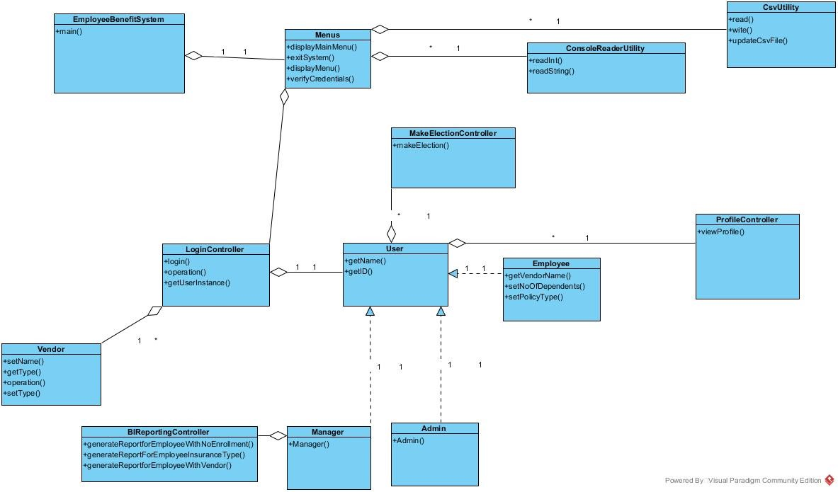

Class-Responsibility-Collaborator card (CRC card)

- Class Name: BiReportingController

Responsibility | Collaborator
Generates Business Intelligence Reports for Managers | Manager  CsvUtility

Responsibility | Collaborator
Validates the permission of the user that is logging in the system | CsvUtility  ConsoleReaderUtility
- Class Name: LoginController

Responsibility | Collaborator
Enables the Employee to select benefit election | Employee
- Class Name: MakeElectioncontroller

- Class Name: Menus

Responsibility | Collaborator
Displays the permitted options that are available for the user to navigate through the system | ConsoleReaderUtility  EmployeeBenefitSystem

- Class Name: ProfileController

Responsibility | Collaborator
Enables the user to manipulate profiles | Admin

- Class Name: Admin
Responsibility | Collaborator
Defines the attributes and capabilities for the Admin | User  ProfileController

- Class Name: ConsoleReaderUtility
Responsibility | Collaborator
Gets the options that the user selects from the screen | Menus  LoginController

- Class Name: Employee

Responsibility | Collaborator
Defines attributes and capabilities of the Employee | User  MakeElectionController

Responsibility | Collaborator
Defines the attributes and the capabilities of the Manger | User  BIReportController
- Class Name: Manger

- Class Name: user

Responsibility | Collaborator
Defines the attribute of the user and extends it to more specific users that will inherent from it | Admin  Employee  Manager  Vendor

Responsibility | Collaborator
Defines attributes and capabilities for the Vendor  (TBD) | User  (TBD)
- Class Name: vendor

- Class Name: CsvUtility

Responsibility | Collaborator
Enables the system to read from CSV files as if it is a database | LoginController  User

- Class Name: EmployeeLogin
Responsibility | Collaborator
TBD | TBD

- Class Name: EmployeeBenefitSystem

Responsibility | Collaborator
The main model that calls menus and starts the whole process | Menus

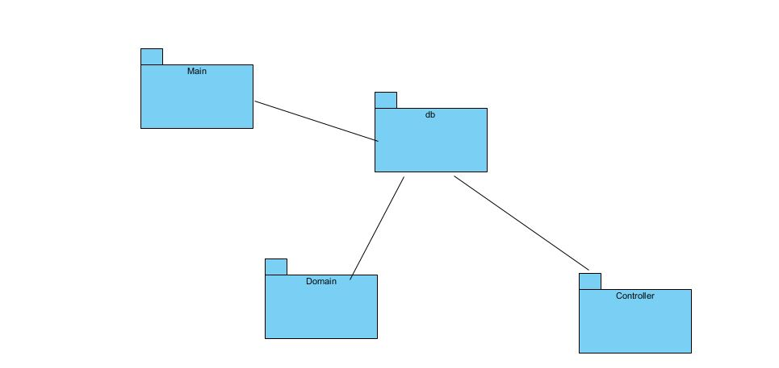
Layers and Packages

The diagram represents the various layers and packages of the application.

Dynamic View: Sequence Diagrams

Use case name: Maintain profile

Scenario name: View employee details

Description: In this scenario, the employee can View personal details (name, empid, vendorName, ssn, policyType, phone, number ofDependents, username, password) which will be stored by the system using a csv file.

Path of the Scenario:
The scenario starts with the condition that the
- system is already running
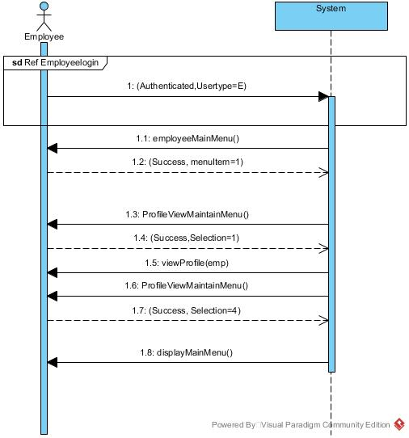
- the employee authenticates himself to the system.
The path for scenario is:
- The system displays the Employee Main Menu to the employee.
- The employee enters the option corresponding to “maintain profile”.
- The system then displays Profile menu to the user.
- The employee enters the option corresponding to “View profile”.
- The system displays the profile of the Employee
- The system displays the profile Main menu
to the employee.
- The employee selects the option
corresponding to logout.
- The system logs out the user from the system.

View Employee details sequence diagram

Use case name: Manage Vendor

Scenario name: Add Vendor details

Description: In this Scenario, the manager adds a vendor to the system.

Path of the Scenario:
The scenario starts with the condition that the
- system is already running
- the Manager authenticates himself to the system.
The path for scenario is:
- The system shows the Manager menu to the manager.
- The manager selects the option corresponding to “Manage vendor”.
- The system then displays vendor menu to the manager.
- The manager selects the option corresponding to “Add vendor”.
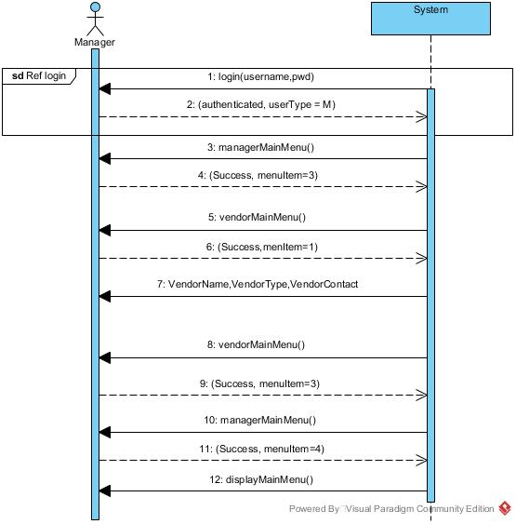
- The manager enters the detail of each item asked by the system and upon completion gives message as “Vendor Updated”
- The system displays the vendor menu to the employee and the user selects the option “go back”.
- The system displays the manager main menu and the employee selects the option corresponding to logout.
- The system logs out the employee.

Add vendor sequence diagram

3. Use case name: Generate BI Reports

Scenario name: shows insurance reports
Actor: Manager

Description: In this scenario, the manager can generate the report which shows all the employees with their registered insurance type.

Path of the Scenario:
The scenario starts with the condition that the
- system is already running
- the manager authenticates himself to the system.
The path for scenario is:
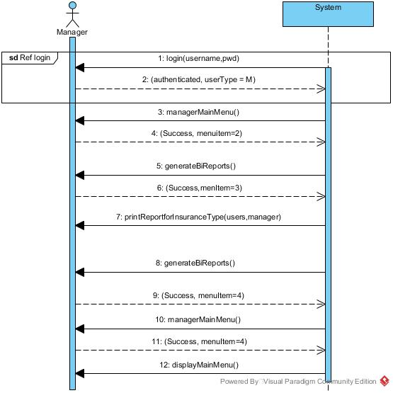
- The system shows the Manager menu to the manager.
- The manager selects the option corresponding to “Generate BI report”.
- The system then reports menu to the manager.
- The manager selects the option corresponding to “Generate report for insurance type”.
- The system displays the report for insurance type.
- The system displays the reports menu again to the manager.
- The manager selects the option corresponding to “go back”
- The system displays the Manager menu and the user can select option corresponding to logout.
- The system logs out the manager from the system. Shows insurance report sequence diagram

Use case name: Make Election
Scenario name: Send application for election

Description: In this scenario, the employee can register for a benefit by applying for the election.

Path of the Scenario:
The scenario starts with the condition that the
- system is already running
- the employee authenticates himself to the system.
The path for scenario is:
- The system displays the Employee Main Menu to the employee.
- The employee enters the option corresponding to “make election”.
- The employee enters the detail of each item asked by the system and upon completion gives message as “your application has been submitted”
- The system displays the profile Main menu to the employee.
- The employee selects the option corresponding to logout.
- The system logs out the user from the system.
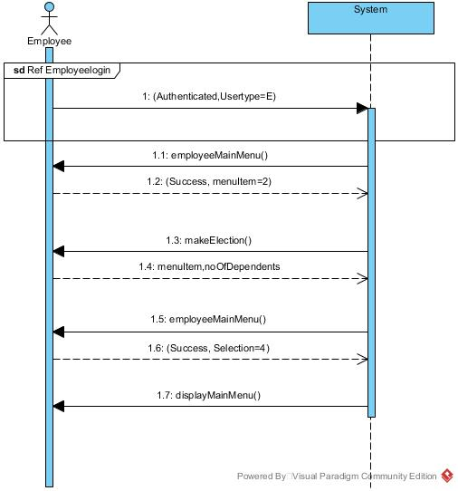

Send application for election sequence diagram

